

|  |
| --- |
| CS 1103 - FR02B  Lab 2 |
| By Ngoc Phuong Anh Nguyen - 3712361  January 2021 |

# ER Diagram

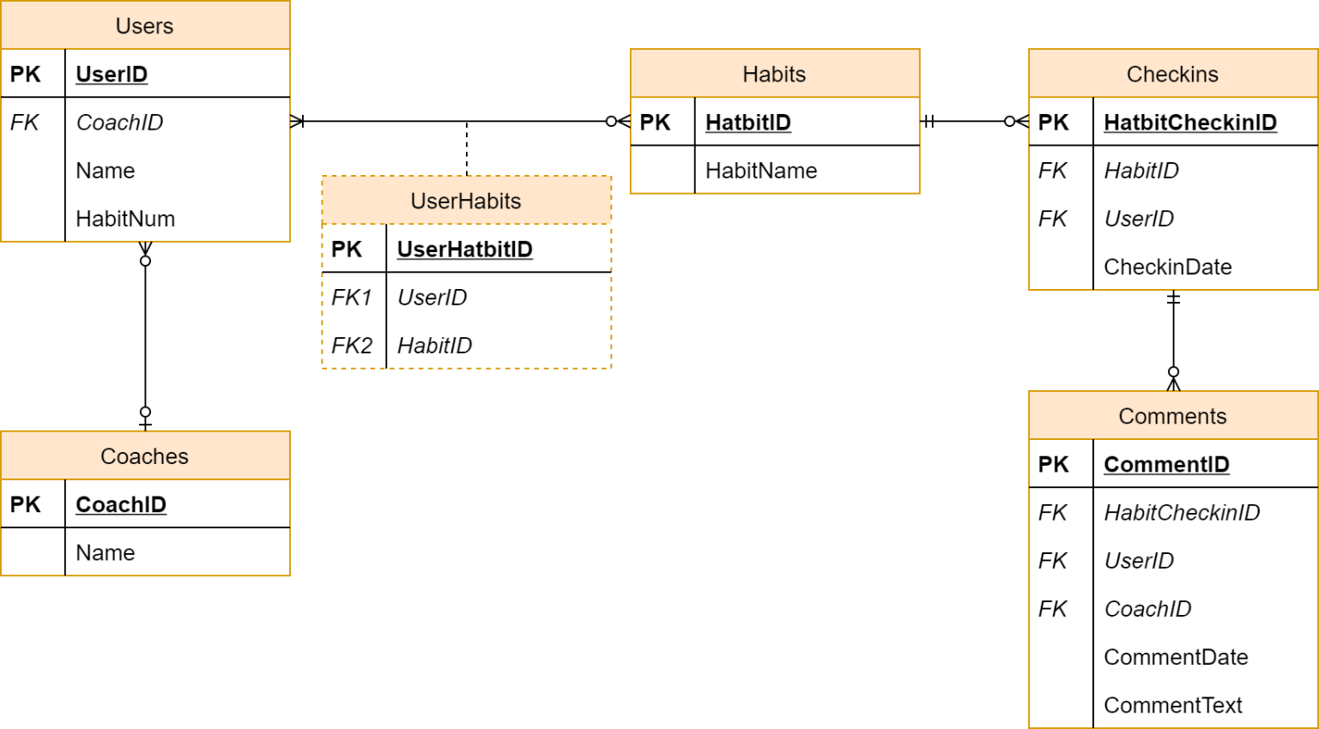

Figure 1: Entity Relationship Diagram

# Requested Information

## The attributes of the User entity:

* UserID
* CoachID
* Name
* HabitNum

## The primary and foreign keys of the Comments entity. For each of the foreign

## keys, identify the entity and item they reference

* Primary key of the Comments entity: CommentID
* Foreign keys of the Comments entity: HabitCheckinID, UserID, CoachID

## The type and cardinality of the Users-Coach relationship

* The relationship of Users – Coach is many-to-one relationship (n,1)

## The type and cardinality of the Users-Habit relationship

* The relationship of Users – Habit is many-to-many relationship (n,n)

## The primary key for the Coach relation/table

* The primary key for the Coach relation/table is CoachID.